Given an undirected tree, return its diameter: the number of **edges** in a longest path in that tree.

The tree is given as an array of edges where edges[i] = [u, v] is a bidirectional edge between nodes u and v.  Each node has labels in the set {0, 1, ..., edges.length}.

**Example 1:**

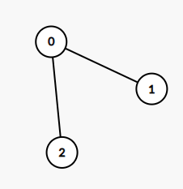

**Input:** edges = [[0,1],[0,2]]

**Output:** 2

**Explanation:**

A longest path of the tree is the path 1 - 0 - 2.

**Example 2:**

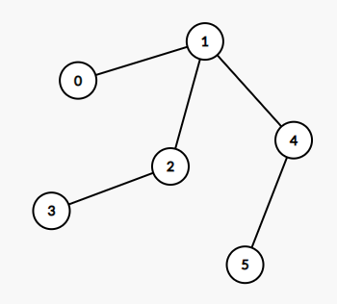

**Input:** edges = [[0,1],[1,2],[2,3],[1,4],[4,5]]

**Output:** 4

**Explanation:**

A longest path of the tree is the path 3 - 2 - 1 - 4 - 5.

**Constraints:**

* 0 <= edges.length < 10^4
* edges[i][0] != edges[i][1]
* 0 <= edges[i][j] <= edges.length
* The given edges form an undirected tree.